AAW

AWS ADVANCED PROJECT-3

**Provisioning EC2 Instance with Lambda**

ARAVIND G KUMAR

**Introduction:**

**AWS Lambda** is a serverless compute service that lets you run code without provisioning or managing servers, creating workload-aware cluster scaling logic, maintaining event integrations, or managing runtimes. With Lambda, you can run code for virtually any type of application or backend service - all with zero administration. Just upload your code as a ZIP file or container image, and Lambda automatically and precisely allocates compute execution power and runs your code based on the incoming request or event, for any scale of traffic. You can set up your code to automatically trigger from 140 AWS services or call it directly from any web or mobile app. You can write Lambda functions in your favorite language (Node.js, Python, Go, Java, and more) and use both serverless and container tools, such as AWS SAM or Docker CLI, to build, test, and deploy your functions.

In order to provision an EC2 Instance with Lambda:

* Create an IAM role.
* First create an IAM role using the JSON script.

{

"Version": "2012-10-17",

"Statement": [

{

"Effect": "Allow",

"Action": [

"ec2:Describe*",

"ec2:CreateKeyPair",

"ec2:CreateSecurityGroup",

"ec2:AuthorizeSecurityGroupIngress",

"ec2:AuthorizeSecurityGroupEgress",

"ec2:CreateTags",

"ec2:DescribeTags",

"ec2:RunInstances"

],

"Resource": "*",

"Condition": {

"StringEquals": {

"ec2:Region": "us-east-2"

}

}

}

]

}

* Give the IAM role a name and create the role.

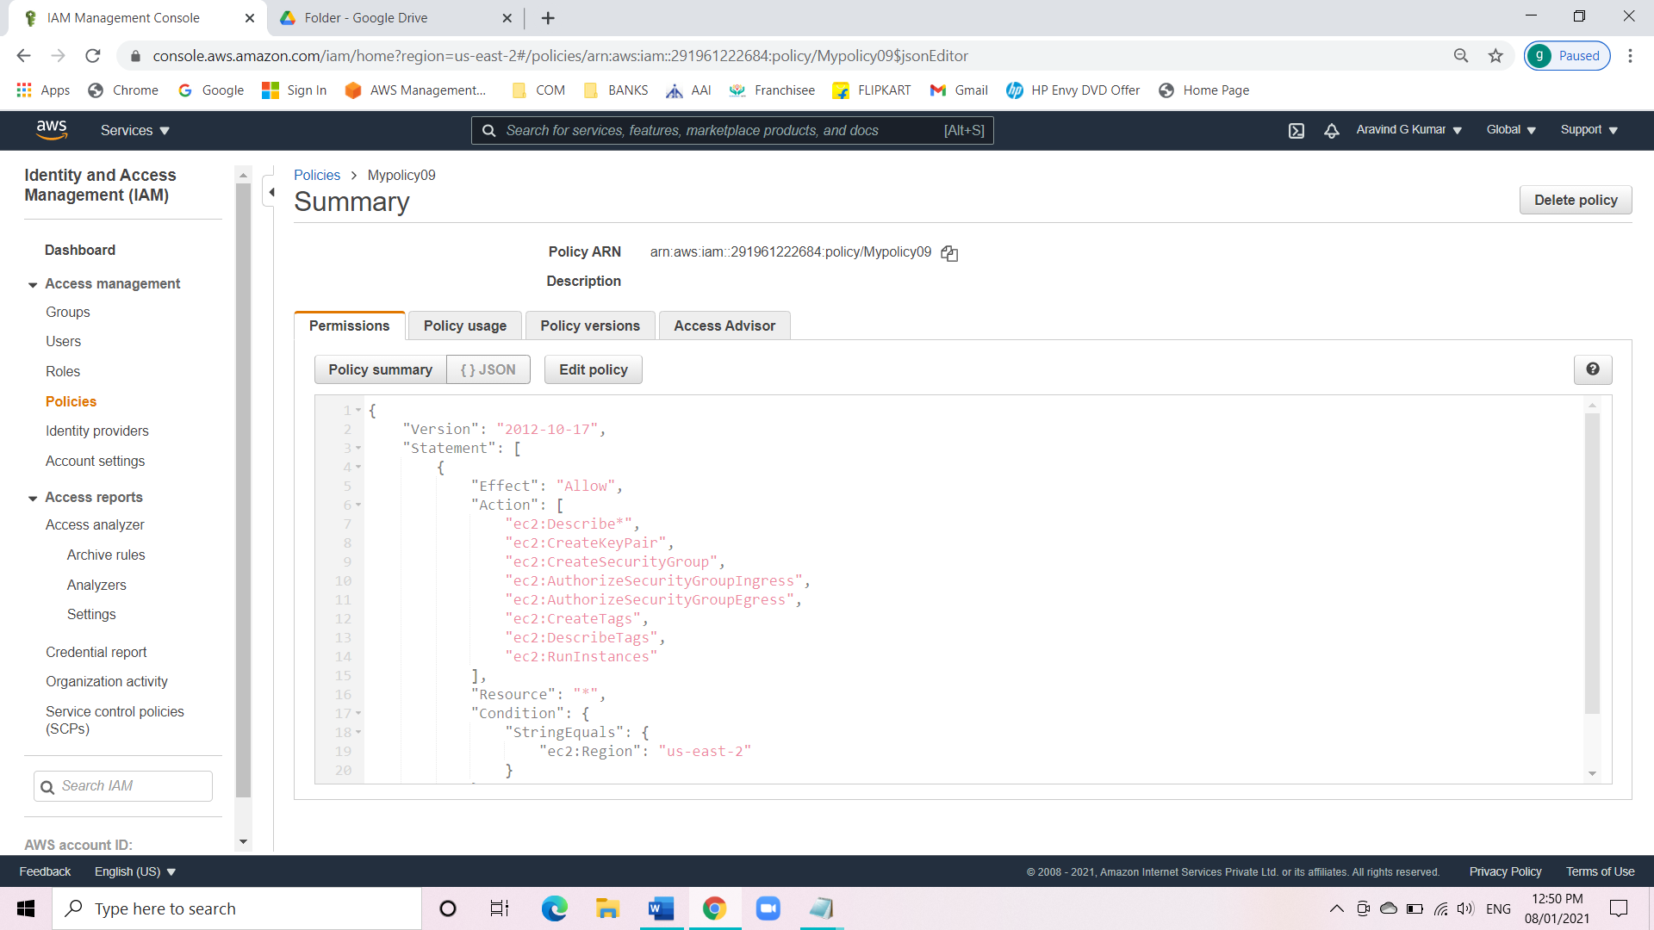

* Create an IAM role.
* Go to role and click on create role.
* Attach the IAM policy which we created with the role.

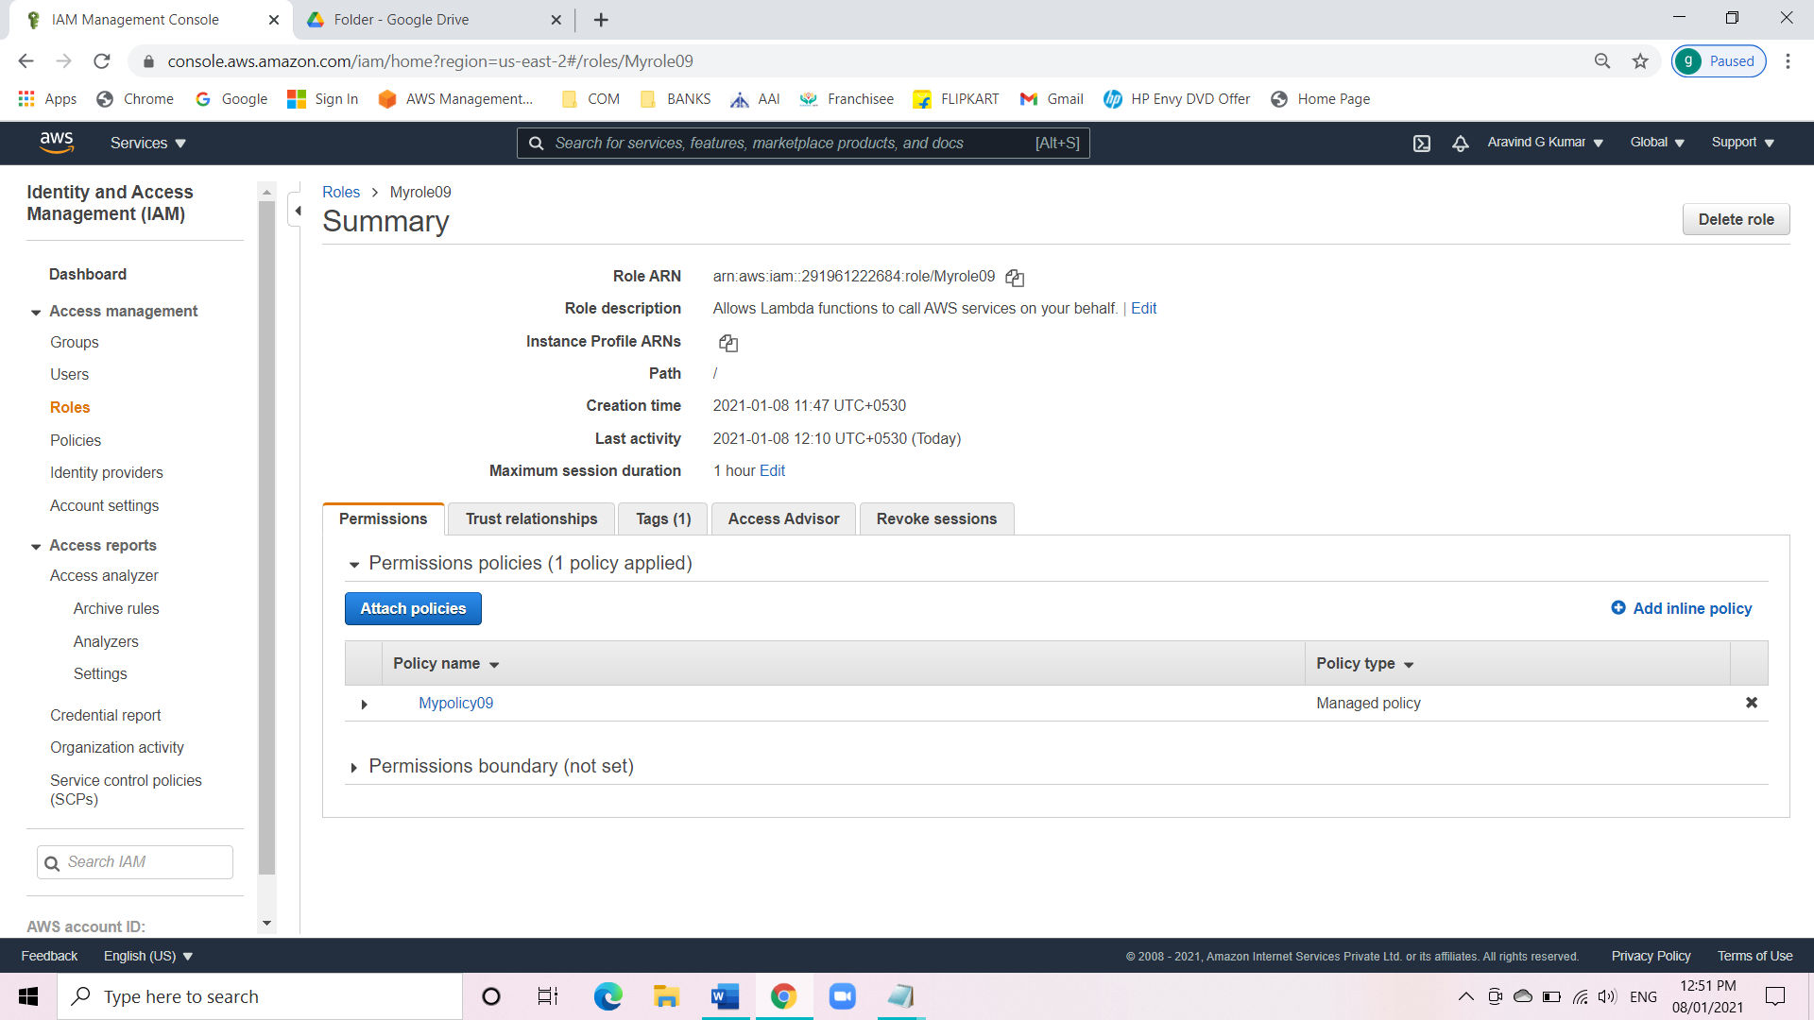

* Creating a Lambda function.
* Navigate to Lambda under the service menu.
* Click on create function.
* Select the runtime as Python 3.8.
* Select the created IAM role and assign.
* Click on create function.
* Move down to my lambda functions and paste the code and deploy the lambda function.

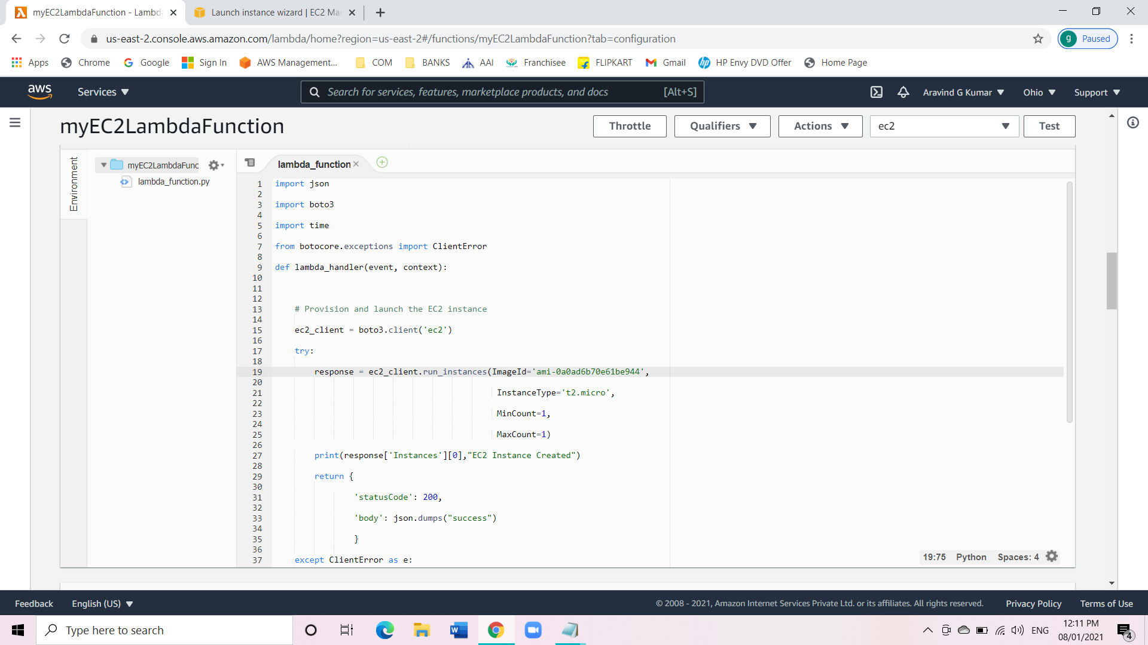

* Now go to basic settings and change the time out to 6 sec.

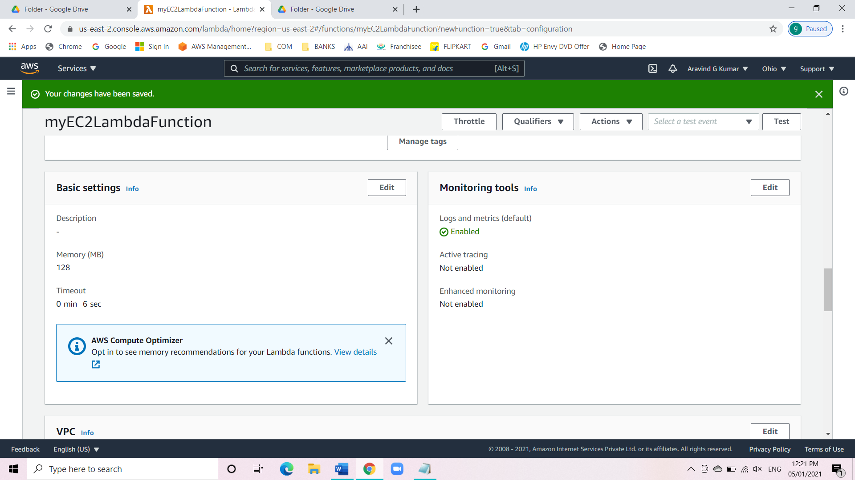

* Create a test even and give the name as ec2.

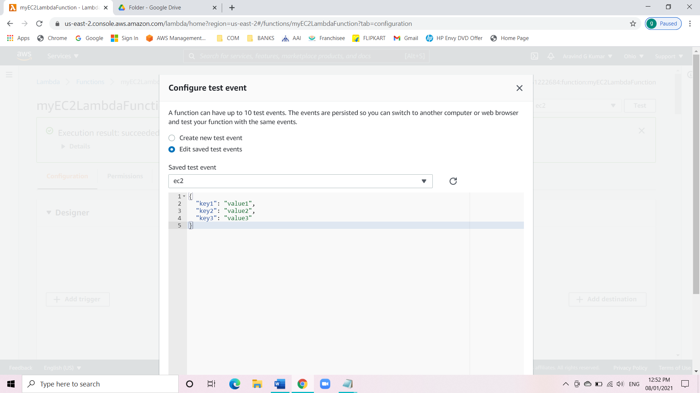

* Now click on test event.
* After the testing we will be able to see a successful message along with the instance details in it.

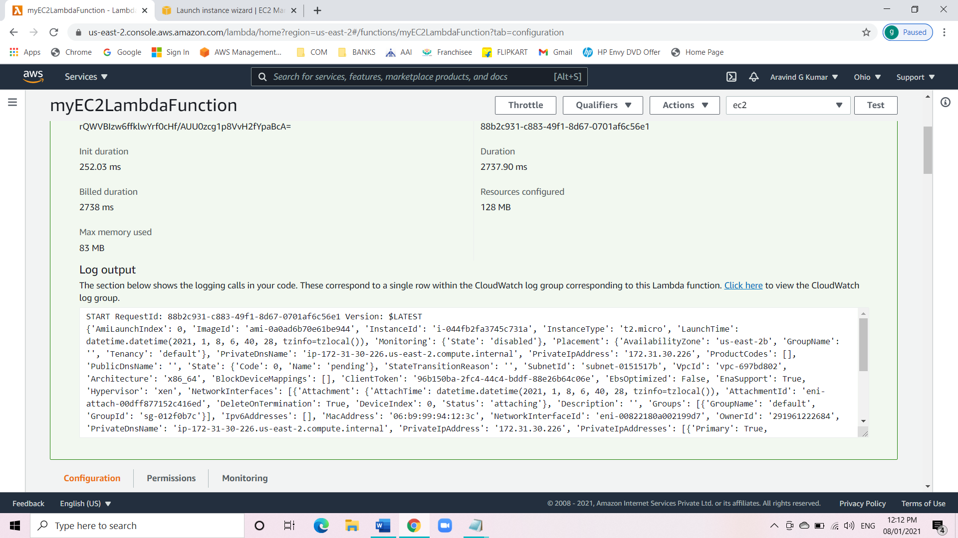

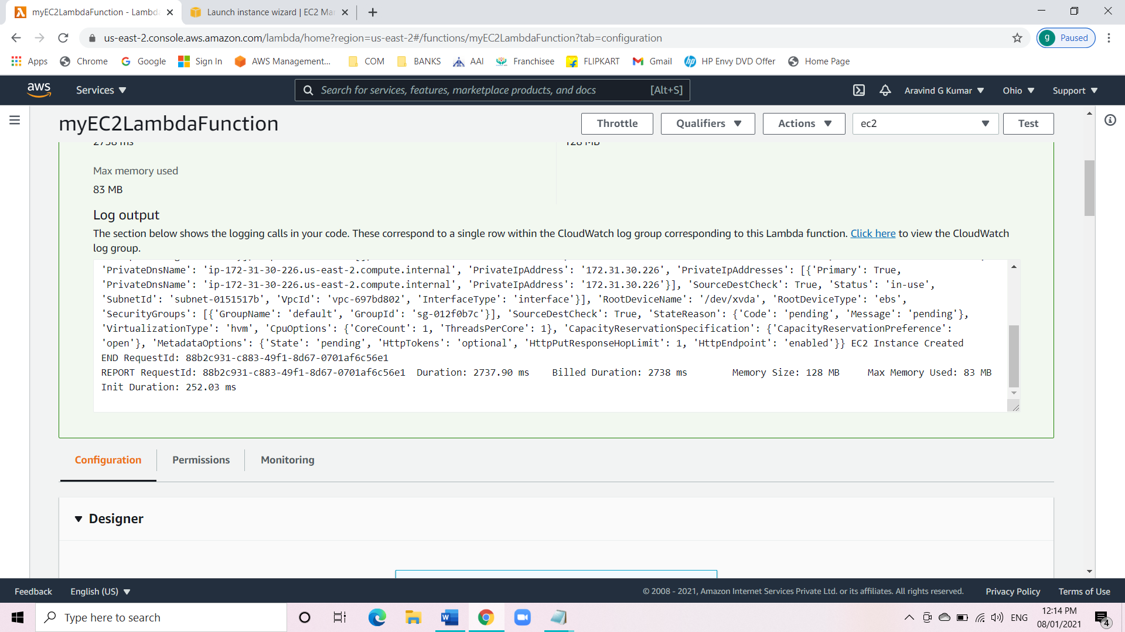

* Check the EC2 console.
* Navigate to EC2 and turn off New EC2 Experience.
* Click in the instance and we can see the details of the EC2 instance we created with Lambda.

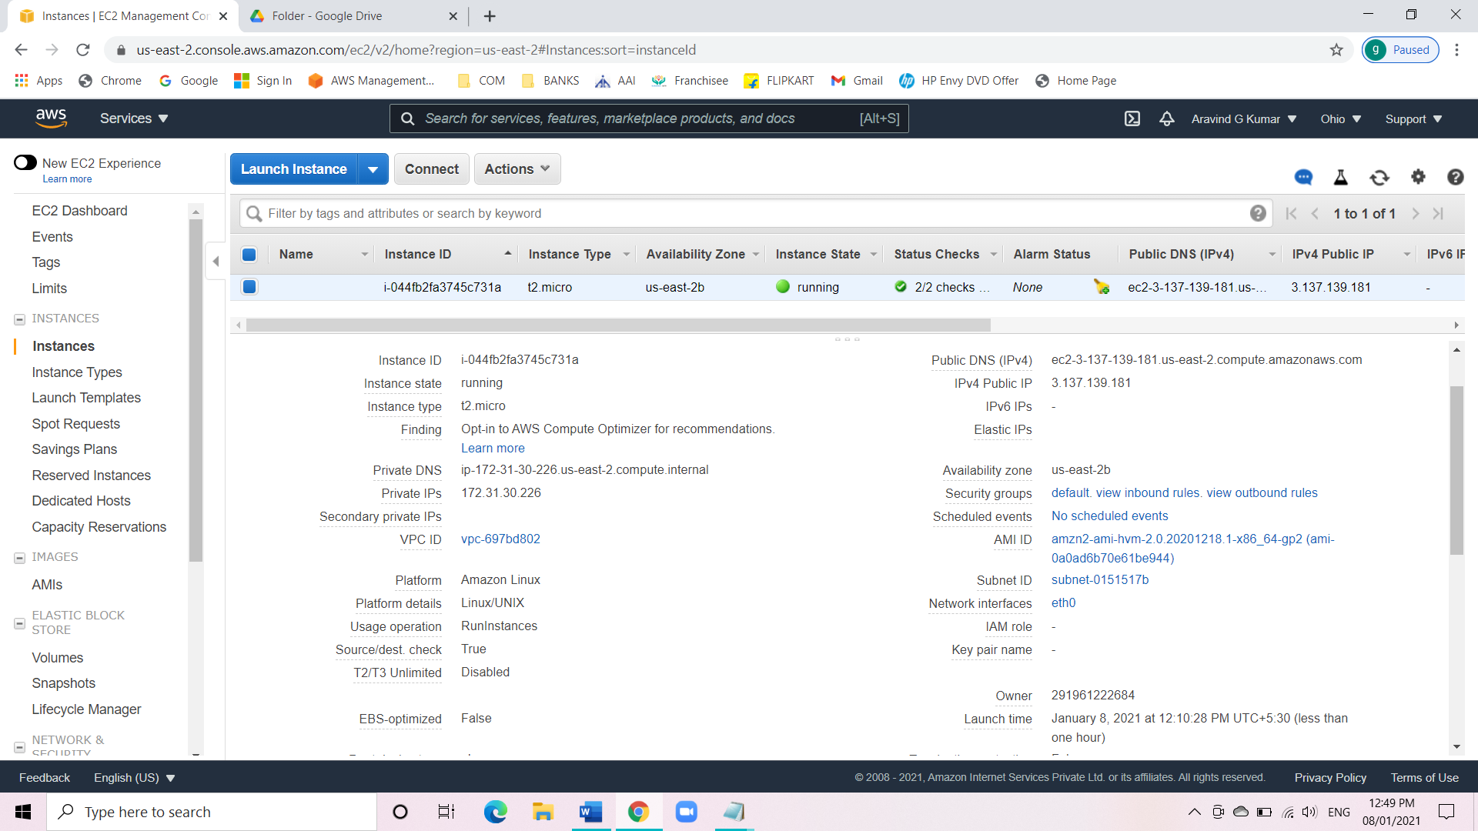

**Conclusion:**

We have successfully launched an EC2 instance with Lambda. The EC2 instance was launched with the give ami id and other instance details.